June 2018

Dear Future Second Graders,

Welcome to second grade! My name is Mrs. Schamberg and I will be your teacher next year. I am looking forward to getting to know each one of you! Second grade is an exciting year and we will learn many new and wonderful things. I am excited for next year and I would love for you to be ready for second grade. Below you will find two things that I would like you to do over the summer.

The first thing that I need you to do is to read every day. Please visit your local library and take out several books that interest you. Many libraries have summer reading programs that you can participate in.

The second thing that I need you to do is your summer assignment. You will need to purchase the Summer Bridge Activities book, Grades 1 to 2. You need to complete Section 1 in the book before school starts. If you would like to work on Sections 2 and 3, I will give you extra credit on your summer assignment grade. You will also need to complete 2 book reports. The 2 book report forms are attached. I have also attached a recommended reading list that we will use in second grade. You can also find a summer reading list in the front of the Summer Bridge Activities book. Please bring your Summer Bridge Activities book, along with the 2 book reports, the first day of school.

Finally, enjoy your summer! Have fun spending time with your family and friends. Don’t forget to spend time with Jesus also!

I look forward to seeing you and your family in September! If you have any questions, please email me at kschamberg@vscaschool.org.

Sincerely,
Mrs. Schamberg

P.S.-Don’t forget to bring all of your school supplies on the first day of school!

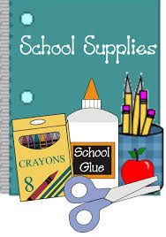
2nd Grade Supply List

Personal Supplies: Please label with your child’s name
- 1 primary journal composition book (K-2nd Grade). (They must have the skip line ruling with a blank drawing space on top of each page. These can be found at Staples, Walmart, or online.)
- 5 regular marble composition notebooks: 2 red, 1 blue, 1 green, 1 purple
- 4 durable, plastic, pocket folders (without prong fasteners)
- 1 white dry erase board (hand held)
- 3 magic rub or pink pearl erasers
- 1 highlighter
- 2 boxes of Crayola washable markers, classic colors, broad line, 8 count
- 2 boxes of Crayola crayons, 24 count
- 1 box of Crayola colored pencils
- 1 package of Crayola water colors
- 1 pencil box (approx. 8 5/8” x 5 ¾” x 2 ½”)
- 1 pair of Fiskars scissors-kids, pointed tip
- 1-12 inch ruler with inches and centimeters
- 1 headphones or earbuds
- The Holy Bible (NIV version) available at: www.Christianbook.com

Communal Supplies:
(Please do not label these supplies as we will be sharing them in the classroom)
- 3 dozen #2 pencils with erasers (Ticonderoga brand recommended)
- 1 large package of construction paper (multicolored)
- 1 container of Elmer’s glue (4 oz)
- 8 large glue sticks
- 2 large box of tissues
- 1 package of baby wipes
- 1 container disinfecting wipes
- 1 large bottle of hand sanitizer
- 1 box of Ziploc sandwich bags (Girls bring!)
- 1 box of Ziploc quart size Freezer bags (Boys bring!)
- 4 dry erase, chisel tip, markers (LOW ODOR PLEASE!!)

H

Supplies to have at home:
- Bible
- Pencils
- Pencil sharpener
- Webster’s dictionary and thesaurus
- Glue
- Ruler (inches and centimeters)
- Scissors
- Crayons/Colored Pencils
- Markers
- Addition and subtraction flashcards

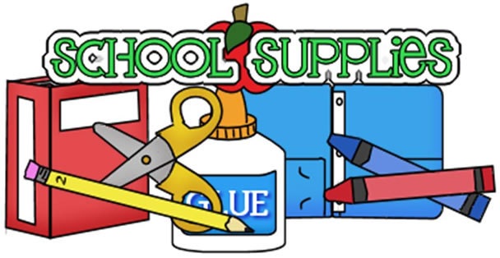

SECOND GRADE READING LIST

Adler, David A. Cam Jansen series

Alexander, Heather Wallace and Grace series

Allen, Joy Hopscotch Hill School series

Anderson, Hans Christian Any Fairy Tale Book

Applegate, Katherine Roscoe Riley Rules series

Arnold, Tedd Fly Guy series

Baker, Olaf Where the Buffaloes Begin

Barracca, Debra The Adventures of Taxi Dog

Barrows, Annie Ivy and Bean series

Bemelmans, Ludwig Any Madeline Book

Benet, Rosemary Johnny Appleseed

Birney, Betty G. Humphrey series

Bishop, Clair Hachet The Five Chinese Brothers

Blume, Judy The Pain and the Great One series

Brett, Jan Beauty and the Beast

Burton, Virginia Mike Mulligan and His Steam Shovel

Byars, Betsy Golly Sisters series

Chaconas, Dori J. Cork and Fuzz series

Cleary, Beverly Any Ramona, Henry Huggins or

The Mouse and the Motorcycle series

Daugherty, James Andy and the Lion

Daniel Boone

Davoll, Barbara Christopher Church Mouse series

DiCamillo, Kate Mercy Watson series

Duvoisin, Roger Petunia

Earhart, Kristin Breyer Stablemates series

Elliott, Rebecca Owl Diaries series

Gag, Wanda Millions of Cats

Hoban, Russell Frances series

Holabird, Katharine Angelina series

Johnson, Any Value Book

Keene, Carolyn Nancy Drew Clue Book series

Kellogg, Steven Pecos Bill, The Island of the Skog

Krulik, Nancy Katie Kazoo series

Leaf, Munro The Story of Ferdinand

Lear, Edward The Owl and the Pussycat

(Illus. by Jan Brett)

Lester, Helen Tacky the Penguin series

Lewis, Beverly Cul-De-Sac Kids series

Lionni, Leo Frederick

Lucado, Max Hermie Series

McCloskey, Robert Blueberries for Sal

One Morning in Maine

McCully, Emily Mirette on the High Wire

McDonald, Megan Judy Moody Series

McKissack, Patricia C. Flossie and the Fox

Miles, Ellen The Puppy Place series

Murphy, Elspeth Campbell Elspeth Campbell Murphy series

Myers, Bill Incredible Worlds of Wally McDoogle

series

Oke, Janette Animal Friends series

O’Ryan, Ray Galaxy Zack series

Osborne, Mary Pope Magic Tree House series

Parish, Peggy Amelia Bedelia series

Park, Barbara Junie B. Jones series

Pennypacker, Sara Clementine series

Potter, Beatrix Any Beatrix Potter Book

Rey, H.A. Curious George series

Reynolds, Peter H. Judy Moody series

Rylant, Cynthia Henry and Mudge series

Seek, Vesta Any Old Ruff Book

Seuss, Dr. Any Dr. Seuss Book

Sharmat, Marjorie Weinman Nate the Great series

Smith, Simon Clay Pot Parable series

Sobol, Donald J. Encyclopedia Brown series

Stilton, Geronimo Geronimo Stilton series

Tangvald, Christine Harder Christine Harder Tangvald series

Teague, Mark Dear Mrs. LaRue

Verna, Aandena Why Mosquitoes Buzz in People’s Ears

Viorst, Judith Alexander and the Terrible, Horrible,

No Good, Very Bad Day

Waber, Bernard Ira Sleeps Over

Lovable Lyle

Waite, Michael P. Any Building Christian Character Book

Ward, Lynd The Biggest Bear

Warner, Gertrude Chandler The Boxcar Children series

Wilder, Laura Ingalls Little House series

Zion, Gene Any Harry Book

