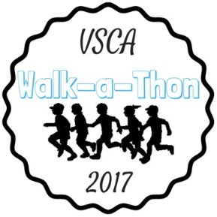
Incentives
 | $ Raised for WAT | Individual Prizes
Registering |  | pedometer
Minimum | $125
Level A | $250 | Italian ice gift certificate |  |  | 1 Dress Down Day coupon
Level B | $400 | Ice cream at Itgens with Mrs. Fowley |  |  | 2 Dress Down Day coupons
Level C  (Pledge Super Star) | $800 | Lunch at Mitchell’s Diner with Mrs. Fowley |  |  | 3 Dress Down Day coupons | 5 drawing entries
Level D | $2,000 | You and a friend go to Dave and Buster’s during a school day with Mrs. Fowley |  |  | 4 Dress Down Day coupons | 10 drawing entries
Level E | $4,000 | You and a friend go bowling and have lunch during a school day with Mrs. Fowley |  |  | 5 Dress Down Day coupons | 15 drawing entries
Level F | $8,000 | 2 movie tickets, $50 Applebees gift card, and basket of games |  |  | 6 Dress Down Day coupons | 20 drawing entries
Level G | $10,000 | 4 movie tickets, $75 Applebees gift certificate, basket of games and activities for the family |  |  | 10 Dress Down Day coupons | 25 drawing entries
Grand Prize for most funds raised: |  | 2 night stay at Kalahari resort and indoor waterpark
1st runner up for most funds raised: |  | 16 GB iPad mini
Drawing Prize: |  | Various gift cards
Early Pledge Due Date: |  | Students who raise $400 by April 21st will get a cupcake of their choice from the Little Sugar Shop
Random Rewards: |  | Prizes will randomly be given out throughout the pledge period to students who are actively getting donations.
Class Prizes
Every class that raises an average of $400/student will get a  pizza party |  |  |  | Teacher receives: $25 Target gift card
Top 3 Classes to fundraise (% to Goal) will compete in a Silly String Battle
Plateau Incentives: (when the school raises x dollars…)
$2,500 |  |  | Bubble Day
$5,000 |  |  | T-shirt Day
$10,000 |  |  | Office staff and administrators Wear Wigs
$20,000 |  |  | Principal Wears a Costume
$40,000 |  |  | Movie Day (popcorn and drinks)
$50,000 |  |  | Mrs. Shanhai will become a Human Ice Cream Sundae.  The top 5 fundraisers will participate in making her into a sundae.

- Individual prizes are not accumulative
- Please do not wait until May 15th to submit donations. Donations should be handed in on Mondays and Fridays as they come in.
- Donated money will be accepted at any time. However, in order to qualify for prizes, donations must be made online or handed in to VSCA by 3:00pm on Monday, May 15th, 2017.

