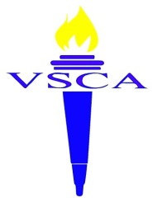
Valley Stream Christian Academy
2017 Matching Funds Donation
The money raised from this campaign will help make a quality, Christian education available to all students.
__I pledge $50/month for 10 months beginning in July 2017 ($500 total donation)
__I pledge $100/month for 10 months beginning in July 2017 ($1,000 total donation)
__I pledge $200/month for 10 months beginning in July 2017 ($2,000 total donation)
__I will make a one-time donation of $________.
*Every dollar donated to this campaign will be doubled up to $10,000 and used specifically for scholarships.
*Donations are tax-deductible.
*Pledges and donations need to be made prior to June 30th in order to be part of the matching funds.
Name: _____________________________________________________
Address:___________________________________________________
City:________________________ State:________ Zip:__________
Phone Number:____________________________________________
Email:_____________________________________________________
Valley Stream Christian Academy 12 E. Fairview Ave. Valley Stream, NY 11580
____I will mail a check monthly, payable to:

____I will set up a recurring payment through the website: www.vscacademy.org/give-to-vsca/
Thank you so much for your generosity. Please direct any inquires to the Director of Development, Breanne Ayala: Bayala@vscaschool.org (516) 561-6122 This form can be mailed to: or emailed to:
Bayala@vscaschool.org
Attn: Breanne Ayala 12 E. Fairview Ave. Valley Stream, NY 11580

