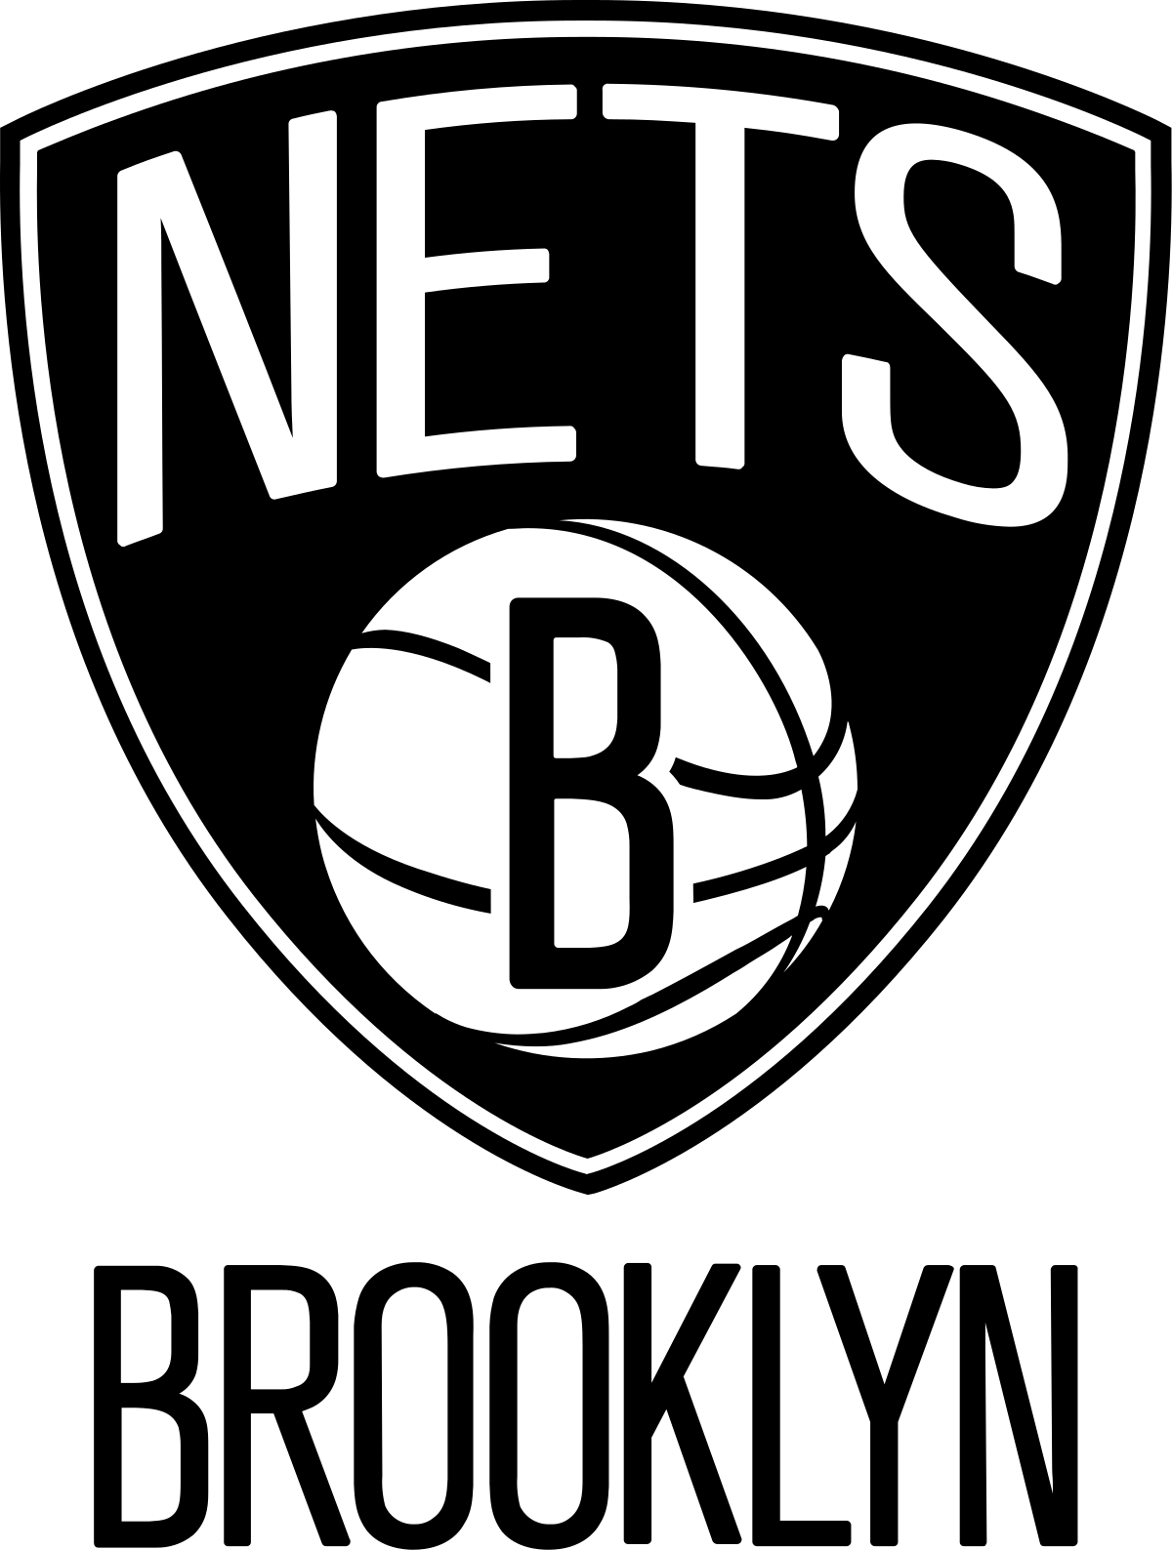
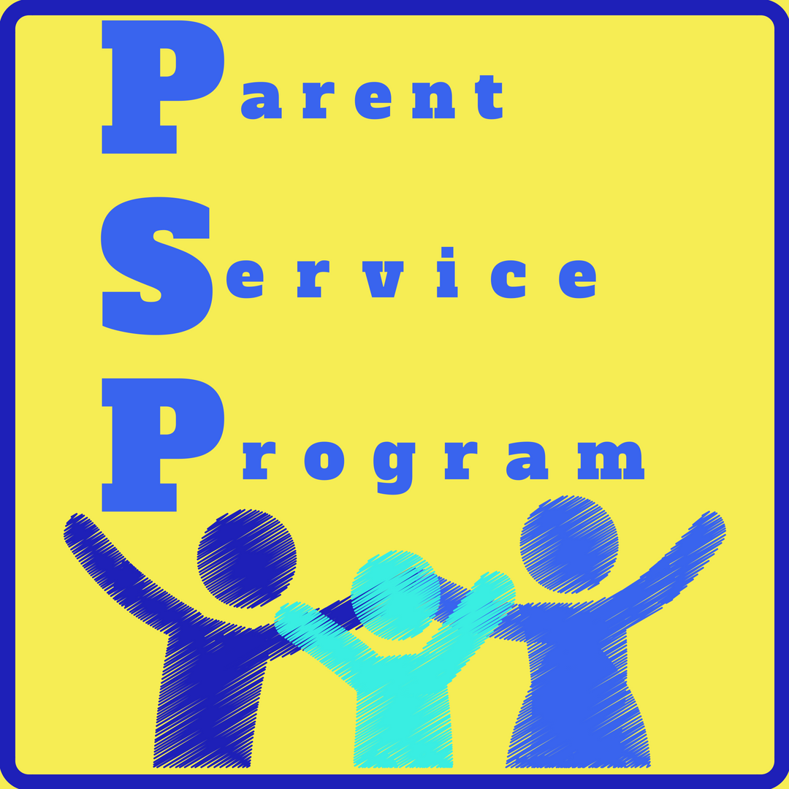
VS
Valley Stream Christian Academy’s

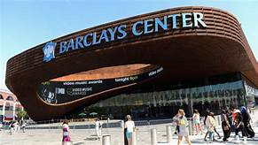

PSP will be sponsoring a fundraiser:
A night out with family and friends on
Friday, February 8, 2019 / Time: 7:30PM
(arrive at 6:15 pm for the Fan Experience)
Place: Barclays Center (Brooklyn)

Tickets are $55.00 per person, which includes:
- a High Five Line on the court from the Brooklyn Nets players to the highest ticket sellers
(first 20 to sell at least 10 tickets)
- Section (200) level seats
- a hoodie from The Brooklyn NETS.
Don’t miss this special event!!!
We will all meet at the Brooklyn Barclays Center.
PSP will earn a portion of each ticket sold!
Student’s Name:________________________________________________ Grade:_______
Parent’s Name:_________________________________________________________________
Phone Number:_________________________________________________________________
Number of Tickets: _______ x $55 each= _______ (total due) Check payable to: Valley Stream Christian Academy
*Please send in completed order form and payment by
January 15th, 2019 to either office. Thank you! If you have any questions, please email: PSP@vscaschool.org

