June 6, 2017 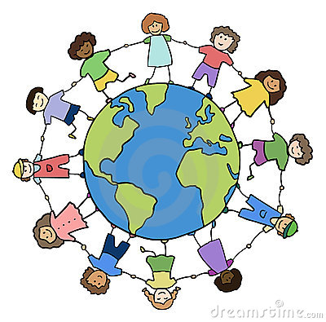
Welcome Families,

Kindergarten is such an exciting time! This is a time for new beginnings, building new friendships, exploring new things and making new discoveries. My passion is to foster a safe environment, where children not only excel academically, but also in character. My desire is for each child to know that they are beautiful and can accomplish anything with God by their side and that God has a specific purpose for their life. This upcoming school year will build a strong foundation that your child will build on for the remainder of their educational years. It is a privilege to be a part of such an important period in your child’s life!

Throughout the year, your child will focus on developing the following:
- Bible knowledge and memorization of scripture
- Letter recognition and sounds
- Letter formation and basic sentence structure
- Reading fluency and comprehension
- Problem Solving strategies
- Basic math operations
- Roles within our community
- Following step-by-step directions and social skills

Attached is a list of supplies that your child will need for the upcoming school year. I hope that you enjoy your summer and I look forward to meeting you in September! Please feel free to contact me with any questions or concerns. I look forward to our partnership.

Sincerely,
Your Kindergarten teacher
Kindergarten Supply List
Please write your child’s name on ALL supply packaging and belongings including sweatshirts, cardigans, lunch boxes, jackets and backpacks.
- 2 packs of #2 pencils (yellow only)**
- 2 packs of glue sticks (pack of 3 or more)**
- 1 bottle of Elmer’s glue (4 fl. oz. or more)
- 2 packs of 8 broad tip washable markers
- 2 boxes of 24 crayons
- 2 large erasers
- 1 pair of children’s scissors
- 4 solid color, plastic folders
- 1, 2-sided dry erase board (one side primary lined, the other side blank)
- 2 packages of thin Expo dry erase markers (please use Expo brand)**
- 1 package of thick Expo dry erase markers (please use Expo brand)**
- 4 PRIMARY composition notebooks (Primary: beginning writing lines)
- 1 pack of construction paper**
- 1 pack of index cards**
- 3 boxes of tissues**
- 1 container of baby wipes**
- 1 container of Clorox Wipes**
- 2 bottles hand sanitizer (8 oz. or more)**
- 1 smock or old shirt
- Change of clothes to keep at school, PLEASE LABEL ALL CLOTHING! (including shirt, pants, socks, underwear and shoes)
**Many items will be put into a community supply.

