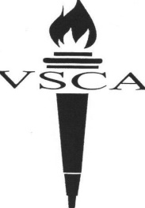
12 E. Fairview Avenue
Valley Stream, NY 11580
Phone: 516-561-6122
516-823-0022
Fax: 516-284-7270
www.vscaschool.org

Valley Stream
Christian Academy
A Ministry of Bethlehem Assembly of God

VSCA EARLY MORNING DROP OFF

Child’s Name____________________________________________Child’s Grade_____
Parent/Guardian Name_______________________ Phone #____________________
Please write in the dates your child will be attending Early Morning Drop-off:
Mon.__________ Tues. __________ Wed.__________ Thurs. __________Fri.__________
Fee: $4 per day, 1st Child
$2 per day, each additional child
Amount Paid: $_______ Today’s Date:_______ Received By:____________________

Parent/Guardian Signature_________________________________________________

This form, along with payment, is required NO Later than the Friday before the week of the above listed dates.

