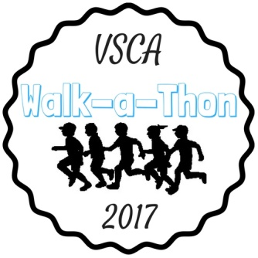
April 3rd, 2017
Today begins a very important, fun, healthy way to raise money for Valley Stream Christian Academy.
VSCA is raising money towards our Annual Fund. This money is used for financial aid and scholarships, to ensure that every student who desires a Christian education can receive one. The Annual Fund is also used to make enhancements to our facilities and educational equipment.
- This is a mandatory fundraiser for all VSCA students. Every student is required to raise at least $125.
Our total school goal is $50,000

- In order to reach our school goal, we are asking each student to strive to raise $400 or more.
- There are incentives for students who go above and beyond (see attached paper)

There are 2 Ways to Raise Funds: Through online donations and cash/check donations
Step 1: Every student needs to have an online account. All funds raised online and with cash/checks will be displayed on the individual student webpages. Go to thegetmovincrew.com .Click on the yellow star on the bottom right corner that says Get Registered Parent Login. Click on the green box that says Click Here to Register. Complete the registration process from there. *If you registered last year, you can log in and re-register your child.
Step 2: Promote! Promote! Promote! Click the Share buttons and send the link to your webpage through email, Facebook, Instagram, etc.
Step 3: Sponsor sheets are also available for students to collect cash and checks from donors. Please fill out donor info and collect the money in the yellow envelope provided. Checks should be made payable to Valley Stream Christian Academy. Sponsor sheets and money should be turned in to the classroom teacher (grades K-5) or homeroom teacher (grades 6-12) using the yellow envelope provided on Mondays and Fridays. Additional sponsor sheets will be sent home and are available on our website: vscacademy.org Click Give, then click Walk-a-Thon 2017. (There are 2 different sponsor sheets- one is to collect from donors and hand in with the money, the other is to mail out to potential donors for them to mail back to VSCA with their money). Also, consider asking your employer if they will make a Matching Funds donation.
Step 4: Donations can be made online at any time. The final day to hand in donations is Monday, May 15th .
(If you need help registering, please contact Mrs. Ayala Bayala@vscaschool.org or call: 516-561-6122)
Event Details:
- Walk-a-Thon date: Wednesday, May 10th (rain date: May 11th )
- Early Pledge Due Date: April 21st
- Final Pledge Due Date: May 15th
Show off your school spirit and wear the color below representing your grade on the day of the WAT:
K, 1, 2= Red 3, 4, 5=Light Blue 6, 7, 8= Green 9, 10= Gray 11, 12= Dark Blue

*Parents- please note that this is a MANDATORY fundraiser. Every student is required to raise at least $125. If the minimum is not met, the parents will have to contribute the difference. If you choose not to participate, you will have to pay $125/VSCA student in the school. If you have any questions, please contact Mrs. Ayala- Director of Development (Bayala@vscaschool.org ).
Thank you!!

