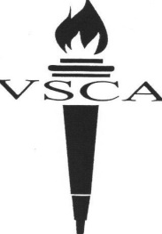
12 E. Fairview Avenue
Valley Stream, NY 11580
Phone: 516-561-6122
516-823-0022
Fax: 516-284-7270
www.vscaschool.org

Valley Stream
Christian Academy
A Ministry of Bethlehem Assembly of God

VSCA EARLY MORNING DROP OFF

Child’s Name____________________________________________Child’s Grade_____
Parent/Guardian Name_______________________ Phone #____________________
Please circle the dates your child will be attending Early Morning Drop Off:
March 2019
MONDAY | TUESDAY | WEDNESDAY | THURSDAY | FRIDAY
 |  |  |  | 1
4 | 5 | 6 | 7 | 8
11 | 12 | 13 | 14 | 15
18 | 19 | 20 | 21 | 22
25 | 26 | 27 | 28 | 29

Fee: $4 per day, 1st Child
$2 per day, each additional child
Amount Paid: $_______ Today’s Date:_______ Received By:____________________

Parent/Guardian Signature_________________________________________________

This form, along with payment, is required NO Later than the Friday before the week of the above listed dates.

