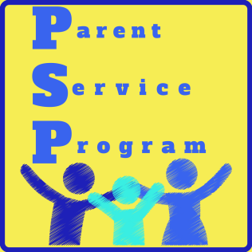

Parent Service Program Hot Lunch
2018-2019

Dear Parents,

On behalf of the Parent Service Program (PSP) of Valley Stream Christian Academy, welcome to our Hot Lunch Program which officially started on Wednesday September 10, 2018.
Please take a moment to read this letter as it will give you valuable information in regards to purchasing Hot Lunch for your child/children, grade K-12th. Coupon Books need to be purchased in order to pay for Wed/Fri. lunches and are available in the following denominations: $30.00, $50.00 and $100.00.
Make checks payable to: Valley Stream Christian Academy. CASH IS NOT ACCEPTED.

ORDERING COUPON BOOKS:
Coupon books can be purchased Monday’s only and will be available for pick up Tuesday to Friday, at the school your child attends by either you or your child. Please make sure your order is accompanied by a check and a completed coupon book order form. Enclose both in an envelope marked ATTN: Mrs. LeBron / “Hot Lunch coupon book order” and submit to your child’s Teacher.
* If you are running low on coupons, be sure to order a new book before you run out.

ORDERING LUNCH:
We are happy to announce Chick-Fil-A will now be available for hot lunch here at Valley Stream Christian Academy! The 2nd Tuesday of every month is “Chick-Fil-A Tuesday” where students/staff can purchase a chicken sandwich or a chicken sandwich meal. Please follow the instructions so you can enjoy this great opportunity.
- Cash/Checks or Money orders will only be accepted for Chick-Fil-A orders. All order forms & payment must be turned in the Friday before Chick-fil-a Tuesday. Any order forms/payment turned in afterwards will be returned home. Unfortunately, late orders cannot be accommodated.
- Please place your form with payment enclosed in an envelope marked ATTN: Mrs. LeBron/ Chick-Fil-A Tuesday
- If for any reason your child is absent, you have the option of picking up your child’s lunch that day until 3pm. Or you can donate the lunch to another student having lunch at that time. (Please Advise)
- **NOTE: Beverages are not provided**
*******************************

Every Wed. we offer Chicken Gyro Delicious hot lunch, where there’s a great selection of meals to choose from. Please take a look at the form enclosed with this form and place your order!
Every Friday is Pizza Day by Ancona! One slice/two slice make your selection and place your order!
Please follow the instructions so you can enjoy these great opportunities.

- Weekly lunch order/coupons must be submitted each Monday for both Wednesday and Friday Hot Lunch.
- Please complete coupons with the following information: your child’s name, grade and lunch item (this information does not have to be written on all the coupons, only one). Staple the coupons together placing the completed coupon on top.
- Please place coupons in an envelope marked ATTN: Mrs.LeBron/ Chicken Gyro Wed. or Friday Pizza
- Children in grades K through 5th must submit lunch orders to their teacher. Grades 6th through 12th submit their orders to their home room teacher.

Although 9th thru 12th grade students are allowed to leave school grounds for lunch, they are welcomed to participate in the Hot Lunch Program. Submit order to home room teacher as well.
- If for any reason your child is absent, you have the option of picking up your child’s lunch that day until 3p.m Or you can donate the Lunch to another student having lunch at that time. (Please Advise)

**NOTE: Beverages are not provided**

EXCEPTION TO MONDAY : In the case of a Monday Holiday or unexpected school closure, feel free to send in your order on Tuesday.

*** Please do not call the School Staff to place Hot Lunch Orders.
(Lunch orders will not be honored)

*** Attached is the Hot Lunch Menu for your reference and Coupon Book Order Forms. Forms are also available on the School Website: vscacademy.org/parents/hotlunchprogram.cfm

In an effort to make this program run smoothly for your child/children, please partner with us in adhering to the above guidelines. Thank you in advance for your cooperation and feel free to contact me via e-mail at dlebron@vscaschool.org should you have any questions.

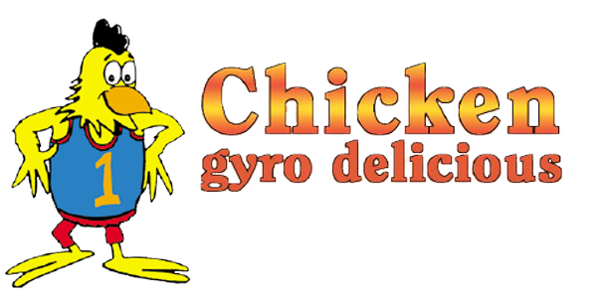
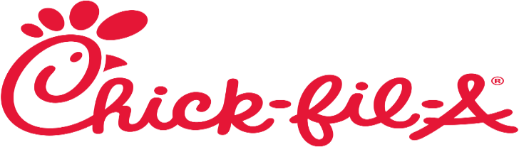

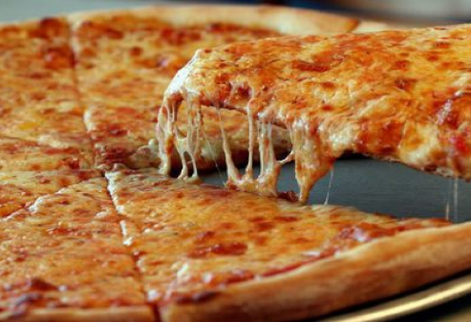 Ancona Pizzeria

