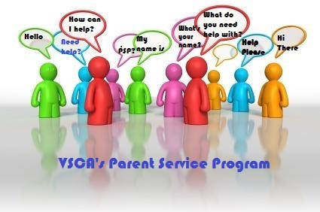
09/12/2016
Parent Service Program Hot Lunch
Dear Parents,

On behalf of the Parent Service Program (PSP) of Valley Stream Christian Academy, welcome to our Hot Lunch Program which officially starts Wednesday September 21st, 2016.

Please take a moment to read this letter as it will give you valuable information in regards to purchasing Hot Lunch for your child/children, grade K-8th. Coupon Books need to be purchased in order to pay for lunches and are available in the following denominations: $30.00, $50.00 and $100.00. Make checks payable to Valley Stream Christian Academy. CASH IS NOT ACCEPTED.

ORDERING COUPON BOOKS:
Order day is Monday and coupon books will be available for pick up at Fairview Avenue Office by either you or your child weekly, on Thursdays after 8:30am. Please make sure your order is accompanied by a check AND a completed coupon book order form. Enclose both in an envelope marked “Hot Lunch coupon book order” ATTN: Mrs. Hough and submit to your child’s Teacher. Books must be signed for on pick up.

ORDERING LUNCH:
Weekly lunch orders must be submitted each Monday ONLY for both Wednesday and Friday Hot Lunch. Late orders cannot be honored. Complete coupons with the following information: your child’s name, grade and lunch item (this information does not have to be written on all the coupons, only one). Staple the coupons together placing the completed coupon on top. UNDER NO CIRCUMSTANCES SEND LOOSE COUPONS, COUPONS NOT COMPLETELY FILLED OUT OR PIZZA AND GYRO COUPONS ATTACHED AS ONE. EACH LUNCH ORDER IS INDEPENDENT. PLEASE REALIZE THAT IF THESE INSTRUCTIONS ARE NOT FOLLOWED, IT LEADS TO UNNECCESSARY WORK AND POSSIBLE ERRORS. Children in grade K thru 5th must submit lunch order to their teacher. For grade 6th thru 8th submit order to home room teacher. Although 9th thru 12th grade students are allowed to leave school grounds for lunch, they are welcomed to participate in the Hot Lunch Program. Submit order to home room teach as well.

**NOTE: Beverages are not provided**

EXCEPTION TO MONDAY SUBMITTAL OF ORDERS: In the case of Monday Holiday or unexpected school closure send in order on Tuesday.

Also, please do not call the School Staff to place Hot Lunch Orders.

Attached is the Hot Lunch Menu for your reference and Coupon Book Order Forms. Forms are also available on the School Website vscacademy.org

In an effort to make this program run smoothly for your child/children, please partner with us in adhering to the above guidelines. Thank you in advance for your cooperation and feel free to contact Mrs. Hough via e-mail at xhough@vscaschool.org should you have any questions.

