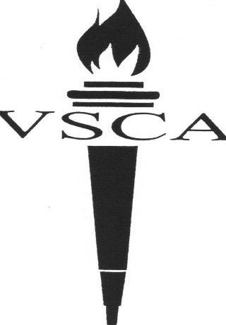
Valley Stream
Christian Academy
A Ministry of Bethlehem Assembly of God

12 E. Fairview Avenue
Valley Stream, NY 11580
Phone: 516-561-6122
516-823-0022
Fax: 516-284-7270
www.vscacademy.org

Valley Stream Christian Academy
CEEB: 335711
www.vscaschool.org
Principal: Aimee Adams
Main Office: 516-561-6122
Established in 1997

Community

Valley Stream Christian Academy is located in Valley Stream NY, about 30 minutes from New York City, in Nassau County, Long Island. The school is a ministry under Bethlehem Assembly of God church. The school consists of four buildings: one Elementary school building, one Jr. and Sr. High school building, and separate buildings for the lunch room and the science lab. All facilities are shared with the church. The student body is culturally diverse with a population that is 61% African American, 25% Hispanic, 7% Caucasian, 4% Asian and 3% other.

School

Valley Stream Christian Academy is a comprehensive K-12 School enrolling 113 students in 2022-2023. Teacher student ratio averages about 1:10. The school opened in the fall of 1997 and graduated its first senior class in the spring of 2001. The school holds membership in ACSI – Association of Christian Schools International, ASCD – Association for Supervision and Curriculum Development, and NHS – National Honor Society.

Curriculum

The academic program consists of eight 42-minute periods per school day. A minimum overall average of 70 is needed to be considered for enrollment. Students are offered 4 years - Math; 4 years – English; 3 years – Science; 4 years – Social Studies; 2 years – Foreign Language; along with standard number of credits for Physical Education, Health, Art and Music. Dual college credit courses and online elective courses are available to students.

AP and Dual College Courses are offered through partnership programs with various colleges and Christian online providers.

At Valley Stream Christian Academy, rigorous coursework promotes academic excellence. Students are well prepared for college level courses.

In addition to the required credits, every student must participate in Community outreaches. K-5th grade classes provide encouraging correspondence to those who are ill or in need. High School students assist at the church’s local community outreach program that serves local families by providing food, clothing and networking.

Graduation Requirements
Per NYS high school graduation requirements, students are required to have the following credits in order to graduate:

English: English 9 (1 credit)
4 credits required American Literature (1 credit)
British Literature (1 credit)
World Literature (1 credit)

History: Global Studies I (1 credit)
4 credits required Global Studies II (1 credit)
American History (1 credit)
Government/Economics (1 credit)

Mathematics: Algebra I (1 credit)
3 credits required Geometry (1 credit)
Algebra II (1 credit)
Pre-Calculus – optional (1 credit)

Physical Education: 9th, 10th, 11th, 12th grades (Total of 2 credits)
2 credits required

Science: Earth Science (1 credit)
3 credits required Living Environment (1 credit)
Chemistry (1 credit)

Foreign Language: Foreign Language I (1 credit)
2 credits required Foreign Language II (1 credit)
Foreign Language III – optional (1 credit)

Required Electives: Bible
- Understanding the Faith (2 credits)
- Understanding the Culture (2 credit)
Health (.5 required credit)
Leadership (1 credit)
Fine Arts 9th – 12th grades (2 credits)
Sociology (1 credit)

Students must also take the SAT and/or ACT in order to graduate.

Rank

School policy does not allow for class rank.

GPA Calculation

Grading Scale:

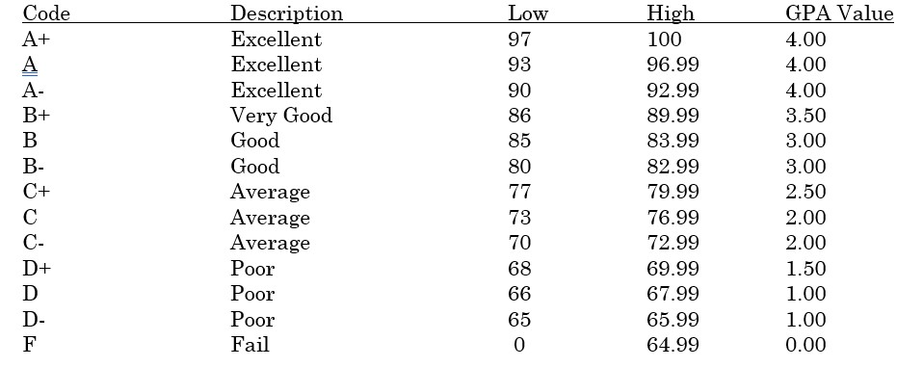

GPA is computed using the above quality points. Beginning with Grade 9, all subjects whether passed or failed, are included in the computation. Standard courses are 1 credit, Honors courses are 1.05 credits, and Dual-College courses are 1.10 credits.

Class of 2023
There were 10 graduates in the class of 2023.

Post-High School placement

- There was a 100% graduation rate of our Senior 2019 graduating class. Students were accepted into the colleges of their choice.

Post Bachelor Degree

- VSCA Graduates have gone on to their Graduate degrees from private, city and state schools. Our Valedictorian for 2013 was also the Valedictorian for Molloy College for 2017. This student has gone on, with a full grant, and is completing his graduate work at SUNY Stony Brook.

Valley Stream Christian Academy students have been accepted into the following colleges:

Adelphi University Fashion Institute of Technology
Barry University Fordham University
Baylor University George Washington University
Berkeley College Gordon College
Bob Jones University Florida Gulf Coast University
Clark Atlanta University Hampton University
Culinary Institute of America Harvard University Extension School
CUNY City College Hofstra University
CUNY Hunter College Houghton College
CUNY John Jay College of Criminal Justice King’s College
CUNY Lehman College Lancaster General College of Nursing & Health Sciences
CUNY Queens College Lee Christian College
CUNY Sophie Davis School of Biomedical Education Liberty University
CUNY York College Lincoln University
Evangel University LIU/CW Post

Manhattan College
Mississippi Women’s College
Molloy College
Moody Bible Institute
Nassau Community College
New York Institute of Technology
New York University
North Carolina Agricultural & Technical State University
Nyack College
Oral Roberts University
Pace University
Pennsylvania Technical College
Pensacola Community College
Southeastern University
St. John’s University
St. Joseph’s College
SUNY Delhi
SUNY Farmingdale
SUNY Old Westbury
SUNY Oneonta
SUNY Rochester
SUNY Stony Brook University
Tuskegee University
University of Tampa
Valley Forge Christian College
Vaughn College

Contact Information

Aimee Adams
Principal
aadams@vscaschool.org

