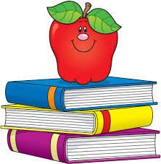
Valley Stream Christian Academy
6-8 English
NColangelo@VSCASchool.org

- 1 – 1 ½” binder with filler paper (Wide Rule filler paper only)
- 1 package of binder dividers
- 1 package of filler paper (to be replenished as needed)
- 1 homework planner
- 3 different color highlighters (light colors only)
- 1 glue stick
- 1 pair of scissors
- 1 package of pens (blue or black ink only)
- 1 fine point sharpie (Black only)
- 1 package of colored pencils
- 1 package of crayons
- 1 package of printer paper
- 2 boxes of tissues
- Electronic device – iPad or laptop only

