Valley Stream Christian Academy
Entering 6th Grade
Summer Reading Assessment
6th Grade English students MUST READ The Egypt Game by Zilpha Keatley Snyder, and answer the following guided questions/literary analysis.

GUIDED QUESTIONS/LITERARY ANALYSIS
Respond to each of the following questions in at least 75 words. Answers should be written in complete sentences. Different examples and references to the text should be used to demonstrate an insightful understanding. Edit for correct grammar, spelling, and punctuation.
Page set up: Name, Date, Title of book, and author. Please make sure your paper is double spaced and in Times New Roman size 12 font.
1. Choose three of the most interesting scenes in the novel and discuss why each scene catches your attention.
2. Discuss one character from the reading. Does he/she go through any changes? Give examples to support your response.
3. Explain three events in the novel and how each one is important.
4. Would you want to read another book with the same characters from your reading? Why or why not?

Due: Friday of the week we return to school.
HAPPY READING!!!
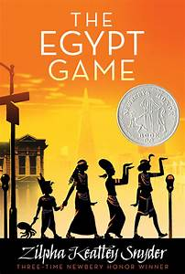

Entering 6th Grade
Summer Reading Assessment Rubric

Name______________________________

Critical Thinking Questions | 100  Excellent | 90  Very Good | 80  Good | 70  Fair | 60  Poor
All four questions are answered in about 75 words each.
Each answer clearly demonstrates an insightful understanding of the plot, characters, setting, conflict, and/or theme.
Different examples were given for each question.
Spelling, grammar and punctuation are correct.
The answers are typed neatly, legibly and with evidence of drafting and/or pre-planning.
Points:

Total points ÷ 5 = _______________

