Entering 8th Grade
Summer Reading Assessment
8th Grade ENGLISH MUST READ Chains by Laurie Halse Anderson, and do the critical thinking questions. Please follow all directions.
CRITICAL THINKING QUESTIONS:
The following questions pertain to the book you have read over the summer. Answer the questions in complete sentences. All responses must be at least 100 words. Different examples and references to the text should be used to demonstrate an insightful understanding of the text (plot, characters, setting, conflict, and/or theme).

*Page set-up: Name, Date, Title of book, and author. Please make sure your paper is double spaced and in size 12 font – Times New Roman

- Record the words and phrases used by the author to describe the setting. Explain how the setting is important to the story.

- Make a list of five gifts that one of the characters might request for his/her birthday. Explain why these gifts are significant to the character.

- Explain the major conflict that the main character faces and how it is resolved.

- What do you think the author is trying to tell us about life and/or people? Use details from your reading to support your answer.

- Would you want to read another book by this author? Why or why not?

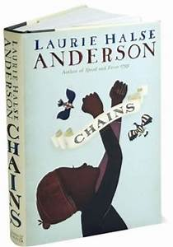

Entering 8th Grade
Summer Reading Assessment Rubric

Name______________________________

Critical Thinking Questions | 100  Excellent | 90  Very Good | 80  Good | 70  Fair | 60  Poor
All five questions are answered in about 100 words each.
Each answer clearly demonstrates an insightful understanding of the plot, characters, setting, conflict, and/or theme.
Different examples were given for each question.
Spelling, grammar and punctuation are correct.
The answers are typed neatly, legibly and with evidence of drafting and/or pre-planning.
Points:

Total points ÷ 5 = _______________

