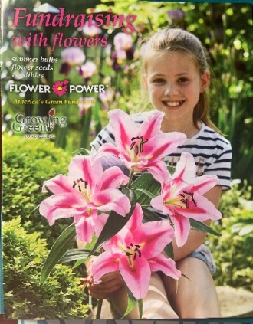
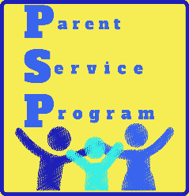

Dear Parents & Guardians,
We are sponsoring a special
FUNDRAISING WITH FLOWERS
this year.
This will benefit our wonderful
school and students.

Our profit is 50%

The sale will run from March 11, 2019 to March 29, 2019

* *
Thank you for your support,
The PSP Committee

The Flower booklet & envelope will go out to all students on March 11, 2019. Please share this magazine with friends, family and neighbors for orders.
Please enclose cash or checks in the assigned envelopes.

Thank you for your participation and we look forward to this successful
fundraiser with Flowers.

Sulma Alvarado & Marcus Hampton
President & Vice – President

